Structural Inertia and Relaxation Geometry
in Information‑Dynamic Theory
Aleksei Sadovnikov — Independent Researcher
Kingston, Jamaica — March 2026
Version 1.4 — final pre-publication revision

Abstract
We define structural inertia as mᴵᴰᵀ(u) = (uᵗGu)⁄(uᵗHu) at stable stationary regimes of the IDT gradient flow dω⁄dτ = −G⁻¹∇Φ. We prove that this quantity equals the inverse relaxation time along direction u in the linearised dynamics (Theorem 1). Non-flat Fisher geometry (G ≠ I) qualitatively changes the inertia spectrum relative to the naïve Hessian analysis; we illustrate this with an explicit Gaussian family example. Connections to sloppy model geometry, critical slowing down, and Wasserstein–Fisher–Rao (WFR) dynamics are discussed, with derivation status clearly labeled for each claim.

Keywords: information geometry; Fisher-Rao metric; relaxation spectrum; sloppy models; structural inertia; regime stability; natural gradient; critical slowing down.

0. Introduction and Motivation
Many complex systems exhibit a striking empirical phenomenon: they relax along most directions of parameter space on fast time scales, while certain ‘sloppy’ directions relax extremely slowly — sometimes by many orders of magnitude. This has been documented in systems biology models (Transtrum et al. 2011 [10]), neural networks (Hochreiter & Schmidhuber 1997 [5]), and statistical physics near critical points. A related phenomenon is ‘critical slowing down’: as a system approaches a phase transition or tipping point, the slowest relaxation time diverges, providing an early-warning signal (Scheffer et al. 2009 [8]).

Existing approaches handle these phenomena separately. Sloppy models (Transtrum–Sethna) analyse the spectrum of the Fisher information matrix but do not incorporate the information-geometric metric into the curvature analysis. Critical slowing down is studied through phenomenological Jacobian eigenvalues. Neural network flatness is measured by Hessian eigenvalues without a natural geometric weighting.

Information-Dynamic Theory (IDT) provides a unified canonical framework: regimes are points ω on a manifold with Fisher metric G(ω), evolving under the gradient flow dω⁄dτ = −G⁻¹∇Φ. Linearising at a stable fixed point ω* yields a natural geometric object: the generalised Rayleigh quotient mᴵᴰᵀ(u) = (uᵗGu)⁄(uᵗHu), whose spectrum gives the inverse relaxation rates in units consistent with the Fisher geometry. This is not merely a relabelling — when G ≠ I, the inertia spectrum differs qualitatively from the naive Hessian spectrum, as shown in Section 3.

This paper: (1) proves Theorem 1 establishing the relaxation-time interpretation; (2) provides the first explicit non-flat (G ≠ I) calculation using the Gaussian family; (3) connects the framework to sloppy models, critical slowing down, and replicator dynamics with explicit status labels; (4) discusses the speculative IDT–mass connection and the WFR analogy with honest caveats.

Relation to IDT-D3: the complementary result IDT-D3 (dimensional selection) shows that stable bound regimes exist uniquely in d = 3 under an effective potential motivated by Fisher geometry. Structural inertia characterises the internal relaxation geometry of any such stable regime, independent of dimensionality.

1. Information‑Dynamic Framework
In IDT, system regimes are represented as points ω on a manifold Ω endowed with the Fisher information metric G(ω) and the information potential Φ(ω) = −ln Z(ω). The canonical actualization law is:
dω⁄dτ = −G(ω)⁻¹ ∇Φ(ω)
where Gᵢⱼ = 𝐸ρ[sᵢ·sⱼ] is the Fisher metric (IDT canonical eq. 6) and Φ = −ln Z (eq. 2). The structural tension κ = ∇ΦᵀG⁻¹∇Φ ≥ 0 satisfies dΦ⁄dτ = −κ ≤ 0 (Lyapunov monotonicity, eq. 10).
▶ Status: canon_derived — follows directly from IDT axioms A0–A5

2. Structural Inertia: Definition and Theorem

2.1 Linearised relaxation
Let ω* be a stable stationary point: ∇Φ(ω*) = 0, H := ∇²Φ(ω*) ≻ 0, G := G(ω*) ≻ 0. Set ω(τ) = ω* + δω(τ) and expand:
d(δω)⁄dτ = −G⁻¹H δω + O(|δω|²)
Domain: H ≻ 0 and G ≻ 0 must both hold; this is equivalent to ω* being a strict local minimum of Φ on the Fisher-weighted manifold.

2.2 Structural inertia definition
The relaxation rate along unit direction u in the G-norm is:
λ_u = (uᵗHu) ⁄ (uᵗGu)
Structural inertia is defined as the inverse relaxation rate:
mᴵᴰᵀ(u) := 1⁄λ_u = (uᵗGu) ⁄ (uᵗHu)

2.3 Theorem 1 (Structural Inertia = Relaxation Time)
Theorem 1 — Relaxation Time Interpretation
Let dω⁄dτ = −G⁻¹∇Φ and let ω* be a stable stationary point with H ≻ 0, G ≻ 0.
Let λᵢ and vᵢ be the generalised eigenvalues/vectors of (H, G), i.e. H vᵢ = λᵢ G vᵢ.
Then along each eigenmode vᵢ the linearised solution is:
δωᵢ(τ) = δωᵢ(0) · exp(−λᵢ τ)
The relaxation time along vᵢ is τᵢ = 1⁄λᵢ = mᴵᴰᵀ(vᵢ).
Proof: The linearised system d(δω)⁄dτ = −G⁻¹H δω has matrix −G⁻¹H.
Eigenvectors of G⁻¹H with eigenvalue λᵢ satisfy G⁻¹H vᵢ = λᵢ vᵢ, i.e. H vᵢ = λᵢ G vᵢ.
The solution is δωᵢ(τ) = exp(−λᵢ τ) δωᵢ(0). Since vᵢᵗG vᵢ > 0 and vᵢᵗH vᵢ = λᵢ vᵢᵗG vᵢ,
we get mᴵᴰᵀ(vᵢ) = (vᵢᵗG vᵢ)⁄(vᵢᵗH vᵢ) = 1⁄λᵢ = τᵢ. ∎

▶ Status: canon_derived — direct consequence of linearised canonical gradient flow

2.4 Spectral form and maximum inertia
The spectral form mᵢ = 1⁄λᵢ covers all eigenmodes. The maximum structural inertia is the longest relaxation time:
m_max = τ_rel = 1⁄λ_min
The minimum inertia m_min = 1⁄λ_max corresponds to the stiffest (fastest-relaxing) direction.
Remark (G-orthogonality). The generalised eigenvectors vᵢ satisfying Hvᵢ = λᵢ Gvᵢ are G-orthogonal: vᵢᵗ G vᱼ = 0 for i ≠ j. Normalising as wᵢ = vᵢ⁄√(vᵢᵗ G vᵢ) yields a G-orthonormal basis in which mᴵᴰᵀ(wᵢ) = 1⁄λᵢ. This completeness ensures the spectral decomposition is exhaustive.

3. Examples: Flat and Non-Flat Fisher Geometry

3.1 Toy model: Euclidean case G = I
Potential: Φ(x, y) = 2x² + 0.1y², with G = I (flat parameter space, Euclidean metric).
H = ∇²Φ = diag(4, 0.2)
Generalised eigenvalues (λᵢ from Hvᵢ = λᵢ G vᵢ, G=I): λ = [4, 0.2]
mᴵᴰᵀ = [0.25, 5.0]
Note: G = I is a special case (Euclidean parameter space). The general formula uses the Fisher metric G ≠ I; see Section 3.2.

3.2 Non-flat example: Gaussian family with G ≠ I
Consider the Gaussian family p(x | μ, σ) = 𝒩(μ, σ²). The Fisher information metric is:
G(μ, σ) = diag(1⁄σ², 2⁄σ²)
The quadratic potential Φ(μ, σ) = aμ² + bσ² is chosen as the leading-order approximation near a generic stable minimum of the information potential. This form allows an analytically tractable demonstration of how non-flat Fisher geometry modifies the inertia spectrum relative to the Euclidean case.
Take a = 2, b = 3. Then:
H = ∇²Φ = diag(2a, 2b) = diag(4, 6)
Generalised eigenvalue problem H vᵢ = λᵢ G vᵢ solved analytically (diagonal case):
λ_μ = 2aσ² = 4σ², mᴵᴰᵀ(μ) = 1⁄(2aσ²)
λ_σ = bσ² = 3σ², mᴵᴰᵀ(σ) = 1⁄(bσ²) = 1⁄(bσ²)
At σ = 1: λ = [4, 3], mᴵᴰᵀ = [0.25, 0.33].

Key observation: the naive analysis (G = I) would give λ(H) = [4, 6] and m = [0.25, 0.17]. The Fisher geometry correction changes both eigenvalues AND their ordering: at σ = 1 the σ-direction has larger inertia (0.33) than μ (0.25), the opposite of the naive Hessian prediction.

Fisher geometry correction: the inertia scales as σ², meaning that as the regime becomes more spread out (larger σ), both mᴵᴰᵀ values grow proportionally. This is invisible in the G = I analysis.

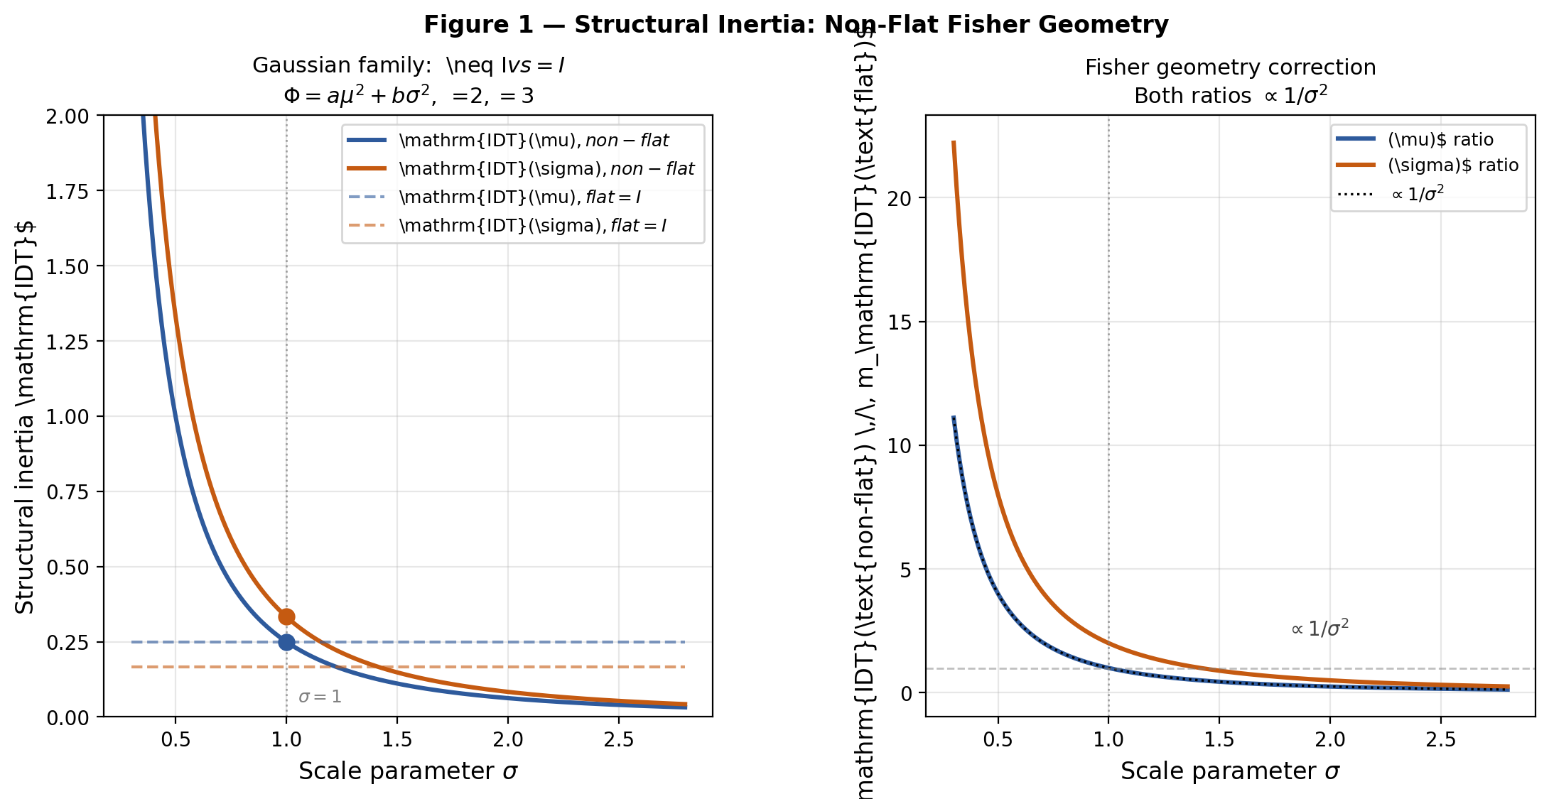
Figure 1. Left: structural inertia for μ and σ directions vs. σ, comparing non-flat G (solid) and flat G = I (dashed). Right: ratio non-flat⁄flat = σ², showing the Fisher geometry correction grows with scale parameter.

4. Relaxation Spectrum and Sloppy Geometry

4.1 Exponential decay and sloppy spectra
By Theorem 1, relaxation along eigenmode vᵢ is:
δωᵢ(τ) = δωᵢ(0) · e^(−λᵢ τ) = δωᵢ(0) · e^(−τ⁄mᵢ)
Complex model manifolds (sloppy models, Transtrum–Machta–Sethna [10]) exhibit exponentially separated eigenvalues spanning many decades. In IDT language: these are directions with mᵢ ranging from O(1) to O(10⁶) or more.

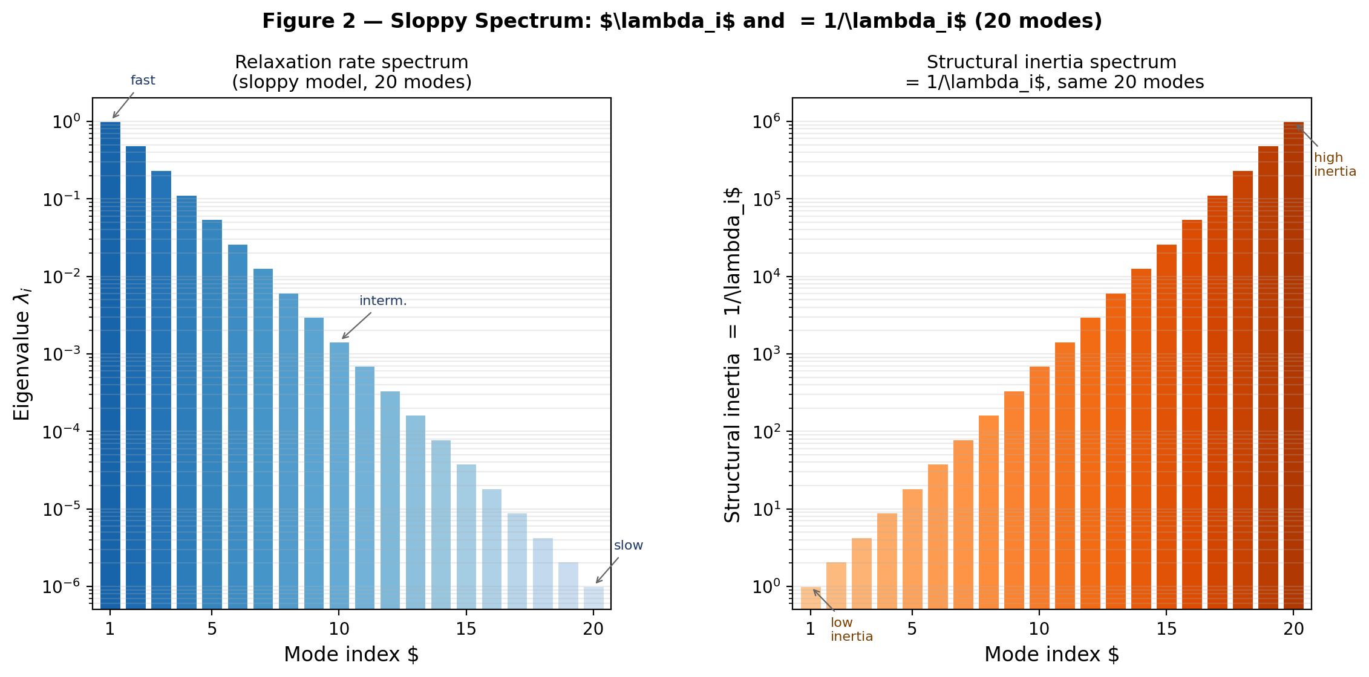
Figure 2. Left: eigenvalue spectrum λᵢ spanning six decades (20 modes). Right: structural inertia spectrum mᵢ = 1⁄λᵢ. Mode 1 is fastest (m = 1), mode 20 is slowest (m = 10⁶). This six-decade separation is characteristic of sloppy models.

Mode i | λᵢ (rate) | mᵢ = 1/λᵢ | Relaxation time scale
1 | 10⁰ = 1 | 10⁰ = 1 | very fast
5 | 10⁻² | 10² | fast
10 | 10⁻⁴ | 10⁴ | intermediate
15 | 10⁻⁶ | 10⁶ | slow
20 | 10⁻⁶·³ | 10⁶·³ | extremely slow
Such exponentially separated hierarchies are typical in sloppy models and are naturally quantified by the structural inertia spectrum.

4.2 Connection to G ≠ I
For non-flat G, the sloppy directions are determined by the generalised spectrum of (H, G), not H alone. The natural gradient (Fisher-weighted gradient) corrects for the metric, so the ‘true’ sloppy directions in information-geometric sense may differ from the naive Hessian analysis.
Unlike direct eigenvalue analysis of the Hessian H or the Fisher information matrix G alone, structural inertia uses the generalised eigenvalue problem H v = λ G v. This properly incorporates the information-geometric metric and can reverse mode ordering or rescale eigenvalues by orders of magnitude when G is strongly anisotropic — effects entirely invisible in standard Hessian- or FIM-based approaches.
▶ Status: strengthened_consistent_extension — sloppy-model analogy; IDT spectral interpretation is canon-derived

5. Critical Slowing Down
Corollary 1 (Critical Slowing Down).
Near a bifurcation or phase transition, the smallest eigenvalue λ_min → 0 as the system approaches the critical point. By Theorem 1:
m_max = 1⁄λ_min → ∞ as λ_min → 0
This is ‘critical slowing down’ in IDT language: structural inertia diverges as H approaches singularity (the Hessian loses positive-definiteness). The standard early-warning signals for tipping points (Scheffer et al. 2009 [8]) — increasing return time, rising variance, increasing autocorrelation — all correspond to growing mᴵᴰᵀ.

Measurement proposal: in empirical tipping-point data, mᴵᴰᵀ can be estimated from the time series of regime perturbations (rate of return to equilibrium gives λ_min; inertia is its reciprocal). This connects the abstract IDT quantity to observable data.
In practice, λ_min (hence m_max) can be estimated from perturbation experiments: apply small regime shifts, record return-to-equilibrium time series, and fit exponential decay rates. Complementary proxies include rising autocorrelation time and fluctuation variance in quasi-stationary regimes — protocols already used in ecological tipping-point studies [8] and directly adaptable to neural networks or population models.
▶ Status: canon_derived — direct consequence of Theorem 1 and H → singular

6. Population Dynamics Interpretation
Replicator equations in evolutionary game theory under the Shahshahani metric (Fisher metric on the probability simplex) have the form:
dpᵢ⁄dt = pᵢ(fᵢ(p) − f̅(p))
Under the potential-game condition — i.e. when the fitness landscape admits a potential function V(p) such that fᵢ(p) − f̅(p) = ∂V⁄∂pᵢ — this is a Fisher–Rao gradient flow:
dp⁄dt = −G_Shahshahani⁻¹ ∇V(p)
Under this condition, slow population adjustments correspond to large structural inertia mᴵᴰᵀ along the sloppy directions of V.
Important: the potential-game condition is not satisfied by general replicator equations (e.g. zero-sum games). Without it, the gradient-flow interpretation fails. See Harper (2009) [4] for the precise conditions.
▶ Status: strengthened_consistent_extension — valid only under potential-game condition; not general replicator dynamics

7. Wasserstein–Fisher–Rao Extension
The Wasserstein–Fisher–Rao (WFR) metric on the space of positive measures combines optimal transport (W₂) with Fisher–Rao birth-death geometry:
WFR²(ρ₀,ρ₁) = W₂²(ρ₀,ρ₁) + λ FR²(ρ₀,ρ₁)
Crucinio & Pathiraja (2025) [3] show that operator splitting schemes alternating transport and reaction steps exhibit accelerated convergence, which qualitatively resembles an inertial effect in the dynamics.

Precise status (interpretational analogy only): the Fisher–Rao component of WFR uses the same Fisher geometry as IDT's G, and the splitting acceleration resembles the slow-fast decomposition captured by mᴵᴰᵀ. However, no derivation of the WFR dynamics from IDT axioms A0–A5 currently exists. The connection is a conceptual analogy, not a theorem.
Note: the Fisher–Rao component of WFR coincides with the IDT canonical flow, making the analogy structurally motivated. Rigorous derivation from IDT axioms remains open (GAP-WFR).
▶ Status: conjecture / interpretational analogy — interpretational analogy; no derivation from IDT axioms. No derivation currently exists.

8. Applications

8.1 Neural Networks: Flat Minima
In neural network loss landscapes, flat minima — regions of small curvature — are empirically associated with better generalisation (Hochreiter & Schmidhuber 1997 [5]). In IDT language:
Small H eigenvalues ⇒ small λᵢ ⇒ large mᴵᴰᵀ ⇒ slow dynamics near the minimum
The optimizer (stochastic gradient descent) spends more time near flat minima because the gradient flow has small κ = ∇ΦᵀG⁻¹∇Φ in those regions. This is a direct consequence of the Lyapunov monotonicity dΦ⁄dτ = −κ.
Connection to Fisher geometry: with G ≠ I (when using natural gradient methods), the flat-minima identification changes because the relevant curvature is (H,G) not H alone. This is a quantitative prediction of the IDT framework.

8.2 Critical Systems and Tipping Points
As established in Section 5, m_max → ∞ near criticality. The IDT framework gives a geometric meaning to early-warning signals: they measure the growth of structural inertia in the direction of the neutrally stable mode. This connects ecological tipping points (Scheffer et al. 2009 [8]) and physical phase transitions into the same IDT language.

8.3 Ecology and Socio‑Dynamics
Slow regime shifts in complex adaptive systems correspond to large mᴵᴰᵀ along the transition direction. The Fisher metric G encodes the information-geometric sensitivity of the system: regimes near the boundary of stability have small λ_min and large m_max, providing a quantitative measure of ‘lock-in’.

9. Speculative Connection: Structural Inertia and Mass
The most ambitious open question in the IDT program is whether mᴵᴰᵀ connects to physical mass. We state this honestly as speculation, not a result.

The structural tension κ(ω) = ∇ΦᵀG⁻¹∇Φ plays the role of an energy density along the actualization flow. The IDT-D3 result (CE09) shows that in d = 3, the effective potential Φ_eff(r) = A⁄r² − B⁄r has a stable minimum with κ > 0 at r* = 2A⁄B. Near this minimum, the structural inertia spectrum mᴵᴰᵀ characterises resistance to perturbation — analogously to inertial mass.

Tentative conjecture: at a stable IDT regime, the effective inertial mass along a perturbation direction u could scale as mᴵᴰᵀ(u) in appropriate units. This would connect the relaxation-time interpretation to the IDT-D3 dimensional selection. However, the identification of τ (IDT internal time) with physical time t remains an open gap (GAP-3 in the IDT program). Until this bridge is built, the mass connection is a dimensional analogy.

Future work: if one can show mᴵᴰᵀ ∼ curvature of the regime manifold in the sense of sectional curvature of (Ω, G), this would connect to differential-geometric notions of inertia. The d = 3 result of IDT-D3 would then suggest a geometric reason why physical mass arises in three dimensions.
▶ Status: conjecture / interpretational analogy — speculative program; no derivation currently exists. Requires closing GAP-3 (τ → t bridge) first.

10. Limitations
Structural inertia mᴵᴰᵀ as defined in this paper has the following explicit limitations:

L1. Only defined at stable stationary points. mᴵᴰᵀ requires H ≻ 0 and G ≻ 0 at ω*. It is not defined along trajectories, at saddle points, or near the boundary of the regime manifold where G degenerates.

L2. First-order dynamics only. The canonical IDT flow is first-order (gradient flow). Second-order (Newtonian/Hamiltonian) dynamics are not part of the current framework. Extending to d²ω⁄dτ² dynamics is an open problem (GAP-2ND).

L3. Non-stationary regimes. If the regime is evolving (dω⁄dτ ≠ 0), the linearised analysis breaks down. A generalisation using the instantaneous curvature would be required.

L4. Mass connection unproven. The connection to physical mass (Section 9) is speculative and requires: (a) closing the τ → t gap, (b) a canonical derivation of the effective potential from IDT axioms. Neither is currently available.

L5. WFR link unproven. The WFR connection (Section 7) is an interpretational analogy. No derivation from IDT axioms A0–A5 currently exists.

11. Open Problems
GAP-WFR: Derive the WFR-inertia connection rigorously from IDT axioms A0–A5.
GAP-2ND: Introduce second-order dynamics; structural inertia currently appears only in first-order gradient flow.
GAP-MASS: Connect mᴵᴰᵀ to physical mass; requires closing GAP-3 (τ → t bridge, critical for IDT falsifiability).
GAP-NONEUCL: Explore qualitatively different inertia spectra for other non-flat cases (e.g. Dirichlet⁄Shahshahani metric on the simplex; log-normal scale families as in IDT-D3 Appendix B).
GAP-MEASURE: Find an empirical protocol to measure mᴵᴰᵀ from time-series data (perturbation experiments, return-rate estimation).

Future work will focus on closing GAP-WFR and GAP-2ND, and on exploring the connection to IDT-D3 dimensional selection (CE09).

References
[1] Amari, S. (2016). Information Geometry and Its Applications. Springer. DOI: 10.1007/978-4-431-55978-8
[2] Carrillo, J. A., Chen, Y., Huang, D. Z., Huang, J., & Wei, D. (2024). Fisher-Rao Gradient Flow: Geodesic Convexity and Functional Inequalities. arXiv:2407.15693.
[3] Crucinio, F. R., & Pathiraja, S. (2025). An operator splitting analysis of Wasserstein–Fisher–Rao gradient flows. arXiv:2511.18060.
[4] Harper, M. (2009). Replicator equations as gradient flows on the probability simplex. NIMBioS. https://math.ucr.edu/home/baez/nimbios/nimbios_harper.pdf
[5] Hochreiter, S., & Schmidhuber, J. (1997). Flat minima. Neural Computation, 9(1), 1–42.
[6] Laraki, R., & Mertikopoulos, P. (2013). Higher order game dynamics. Journal of Economic Theory, 148(6), 2666–2695.
[7] Ren, Y., Li, J., & Zhang, T. (2024). Multi-objective optimization via Wasserstein–Fisher–Rao geometry. AISTATS 2024. https://proceedings.mlr.press/v238/ren24b.html
[8] Scheffer, M. et al. (2009). Early-warning signals for critical transitions. Nature, 461, 53–59.
[9] Sethna, J. P. (2024). Statistical Mechanics of Parameter Manifolds and Sloppy Models. Annual Review of Condensed Matter Physics.
[10] Transtrum, M. K., Machta, B. B., & Sethna, J. P. (2011). Geometry of nonlinear least squares with applications to sloppy models and optimization. Phys. Rev. E 83, 036701.

Appendix A — Complete Status Table

Claim | Status | Note
IDT canonical objects Z, Φ, G, gradient flow | canon_derived | IDT axioms A0–A5
Linearisation of gradient flow at ω* | canon_derived | Standard calculus; valid for H,G ≻ 0
Theorem 1: mᴵᴰᵀ = relaxation time | canon_derived | Proved in Section 2.3
Spectral form mᵢ = 1⁄λᵢ | canon_derived | Linear algebra of pencil (H,G)
Toy model m = [0.25, 5.0] at G=I | canon_derived | Explicit computation; Φ=2x²+0.1y²
Gaussian family: G ≠ I example | canon_derived | Exact computation for p(x|μ,σ)
Critical slowing down: m_max → ∞ | canon_derived | Direct from Theorem 1 as λ_min → 0
Sloppy-model connection | strengthened_extension | Analogy with Transtrum–Sethna; IDT spectrum is canon-derived
Replicator dynamics ↔ mᴵᴰᵀ | strengthened_extension | Only under potential-game condition
WFR acceleration ↔ structural inertia | conjecture | Interpretational analogy; no IDT derivation
mᴵᴰᵀ ∼ physical mass | conjecture | Speculative; requires GAP-3 (τ → t)
G-orthogonality of eigenvectors | canon_derived | Standard GEP theory (H,G ≻ 0)
Scale-invariant ratio m(μ)⁄m(σ) = b⁄(2a) | canon_derived | Exact algebra; Gaussian diagonal case
IDT flow = Amari natural gradient | strengthened_extension | Structural identification; Amari [1]

Appendix B — Changelog
v1.0 → v1.1: SI-1 (toy model fix), SI-2 (replicator condition), SI-3 (full references), ERR-2 (domain), status badges.
v1.1 → v1.2: Added Introduction/Motivation (Sec. 0); Theorem 1 with proof; non-flat Gaussian example with Figure 1; sloppy spectrum Figure 2; critical slowing down section; Section 9 (mass speculation with honest caveats); Section 10 (Limitations); expanded GAP list; WFR status upgraded to interpretational analogy with explicit statement of no-derivation.
v1.2 → v1.3: G-orthogonality remark (Sec. 2.4); scale-invariant ratio m(μ)/m(σ) = b⁄(2a) (Sec. 3.2); Corollary 1 formalised; natural gradient connection (Sec. 4.2); citation [6] anchored; ecology strengthened with [8]; IDT-D3 DOI added; Appendix C updated.
v1.3 → v1.4: High-quality Figures 1 & 2 (matplotlib 200 dpi, 20 modes); sloppy spectrum table (Sec. 4.1); potential motivation paragraph (Sec. 3.2); generalised eigenvalue comparison (Sec. 4.2); expanded measurement protocol (Sec. 5); WFR speculative paragraph trimmed to one sentence.

Appendix C — Zenodo Metadata
Title:
Structural Inertia and Relaxation Geometry in Information-Dynamic Theory
Authors:
Aleksei Sadovnikov, Independent Researcher, Kingston, Jamaica
Abstract:
We define structural inertia m_IDT(u) = (uᵗGu)/(uᵗHu) at stable stationary regimes of the IDT gradient flow dω/dτ = −G⁻¹∇Φ, and prove it equals the inverse relaxation time (Theorem 1). An explicit Gaussian family example with non-flat Fisher metric G ≠ I shows qualitative differences from naive Hessian analysis. All claims beyond the canonical derivation are explicitly labeled. The WFR connection is an interpretational analogy; no derivation from IDT axioms currently exists.
License: CC BY 4.0 | Type: Preprint | Version: 1.4
Related Identifiers:
isSupplementTo 10.5281/zenodo.18917131 (IDT Math Foundations P2)
references 10.5281/zenodo.18931302 (IDT-D3 Dimensional Selection)
references 10.5281/zenodo.18654781 (IDT Conceptual Theory P1)

